Warning Signs of Excessive Stress

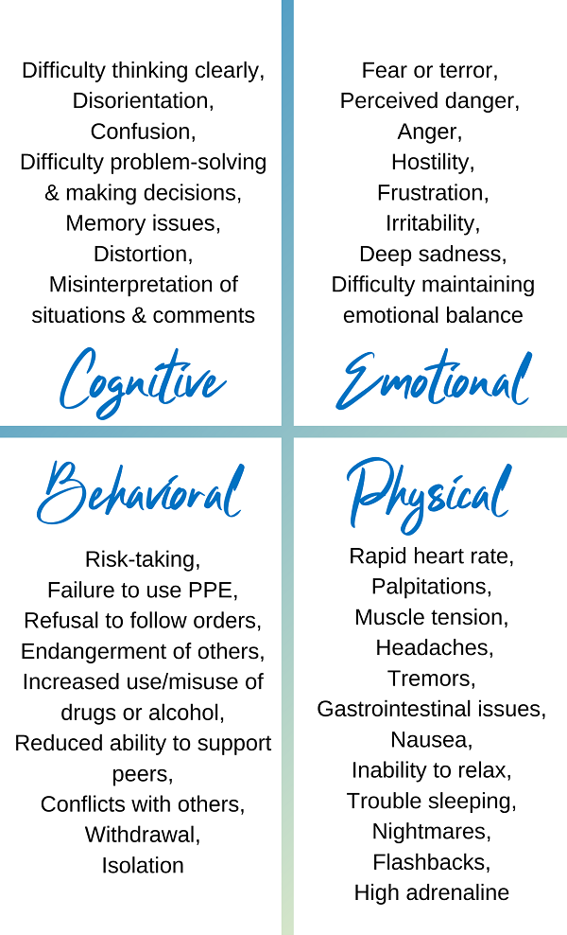

If you have concerns about yourself or a team member, please see your manager and/or reach out!

National Suicide Prevention Lifeline: 988
National Crisis Text Line: Text “4hope” to 741741
Domestic Violence Help Line: 330-453-SAFE (7233)
Veterans’ Crisis Hotline: 988, press 1

Warning Signs of Excessive Stress

If you have concerns about yourself or a team member, please see your manager and/or reach out!

National Suicide Prevention Lifeline: 988
National Crisis Text Line: Text “4hope” to 741741
Domestic Violence Help Line: 330-453-SAFE (7233)
Veterans’ Crisis Hotline: 988, press 1

