Question: I have e-stops on my machines, what are the safety requirements for them?

Answer: OSHA details in 1910.144(a)(1)(iii) Stop. Emergency stop bars on hazardous machines such as rubber mills, wire blocks, flat work ironers, etc., shall be red. Stop buttons or electrical switches which letters or other markings appear, used for emergency stopping of machinery shall be red.
However, OSHA requirements for E Stops are limited, but NFPA 79 Electrical Standard for Industrial Machinery has additional guidance. This is a consensus standard that can be enforced by OSHA.
Definition: E Stops come in many shapes and sizes. The most common is the red mushroom button with a yellow background. Other types of E Stops include pull-cord operated, push-bar, rod switches and foot operated switches with out mechanical guards.
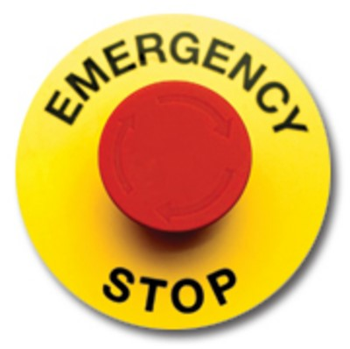
Purpose: These devices are designed to be E Stops not E Shut offs. The difference is an E Stop is designed to shut down the equipment quickly in the event of an emergency. An emergency shut off is designed to shut power off to the machine.
Type: NFPA 79 has two categories for stopping requirements for E Stops. Category 0- Disconnection and Category 1- Controlled. Category 0 disconnects the actuators, equipment power, or motor in the event of an emergency. The Category 1 allows power to the machine actuators until a stop is achieved then power is removed.
Reset requirements: Once an E Stop has been activated it must be reset. Reset should be achieved by one of three ways: turning a key, pulling a button, or rotating a button.
Location: There is no specific location for E Stops but they should be readily accessible ( with in an arm’s length) for the operator where E stop is required.
Testing of E Stops is not spelled out in NFPA 79, but it does say that “ The functions of electrical equipment, particularly those related to safety and safeguarding, shall be tested and documented.” If you have questions or concerns, please contact your BWC safety Consultant.

